Experiment-4
AIM: Design Butterworth and Chebyshev filter using bilinear transformation method.

Theory: The bilinear transformation method is commonly used to design analog filters and then convert them into digital filters. This method maps the analog frequency response to the digital frequency response using a bilinear transformation.

The Butterworth and Chebyshev filters are two commonly used filter types. The Butterworth filter has a maximally flat frequency response in the passband, while the Chebyshev filter allows for a sharper transition between the passband and the stopband at the expense of ripples in either the passband or stopband.

Program and their respective outputs:
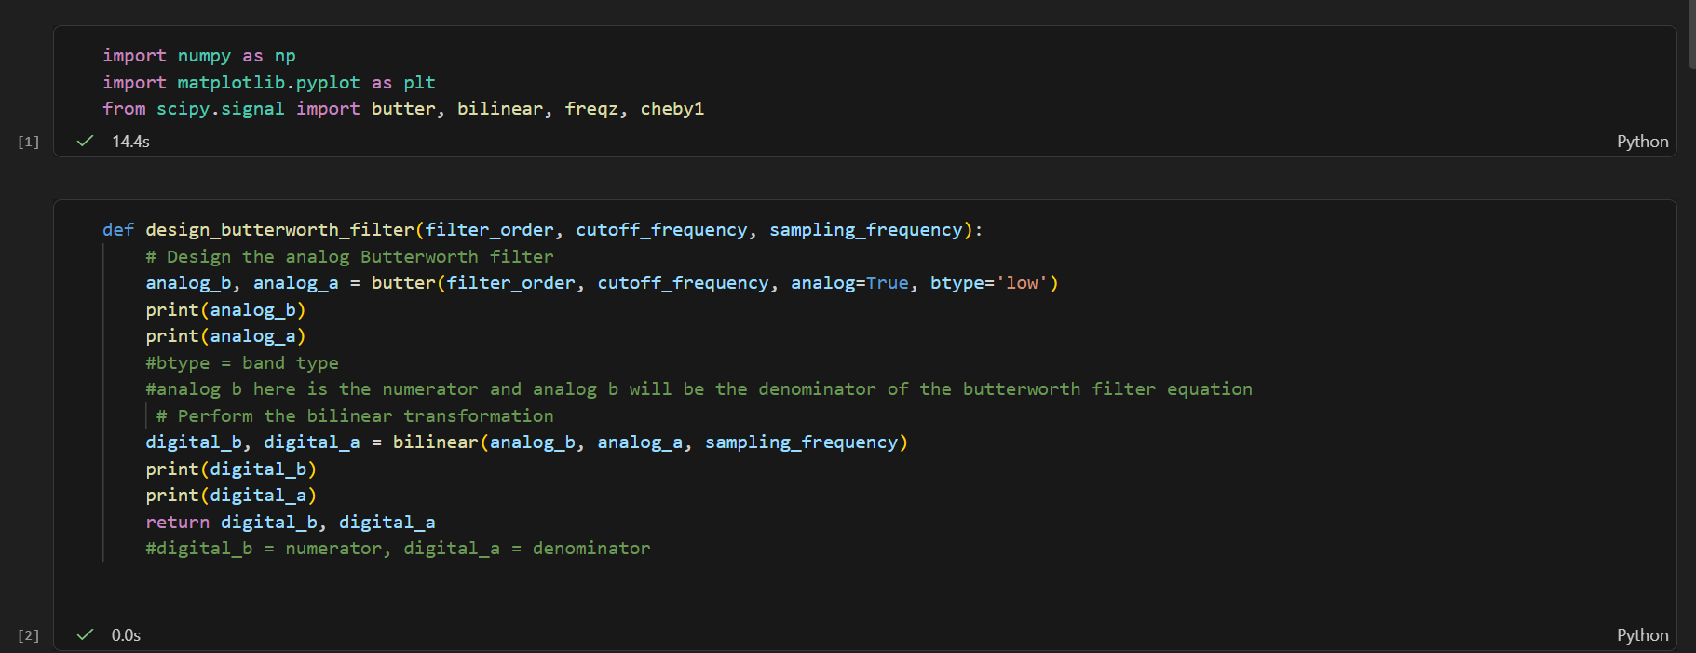

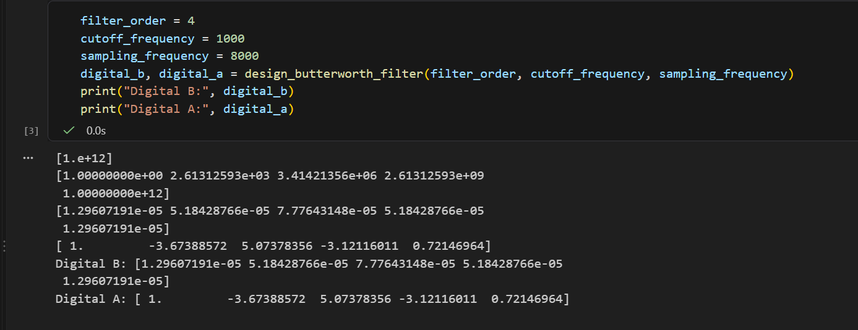

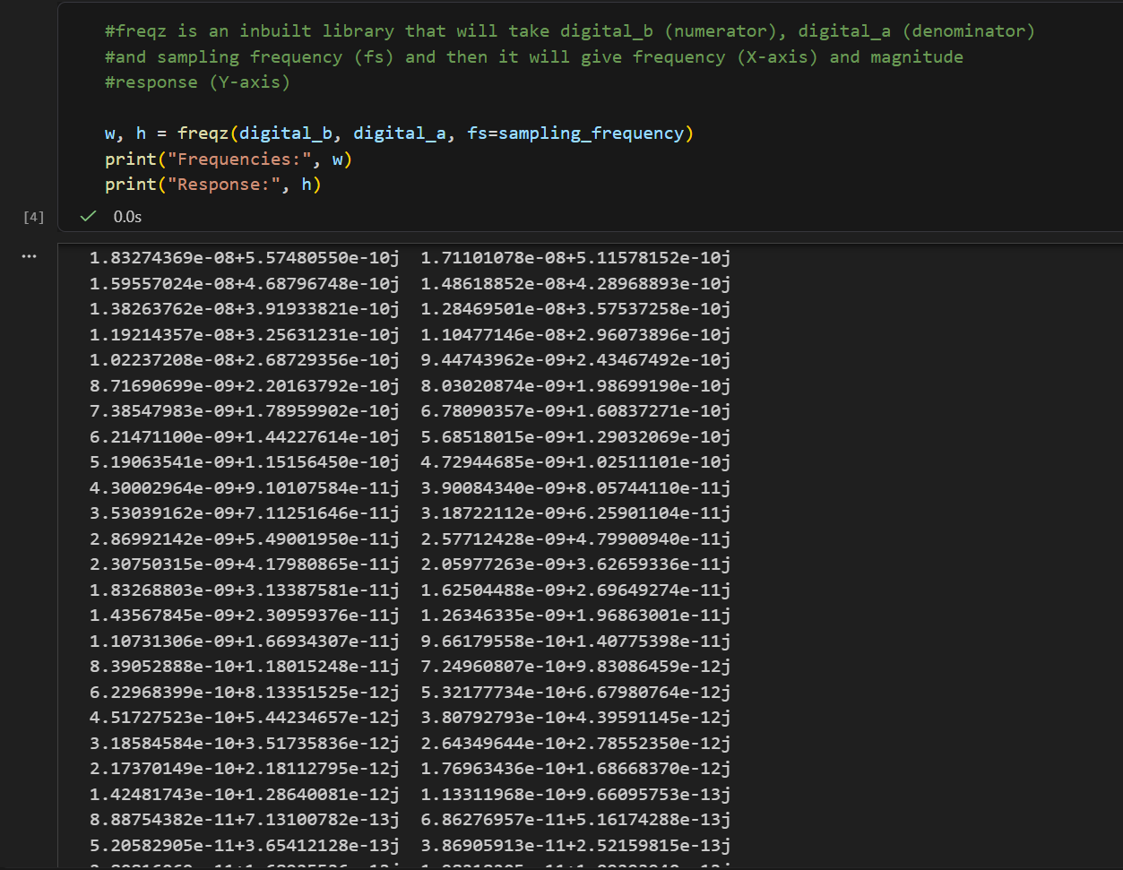

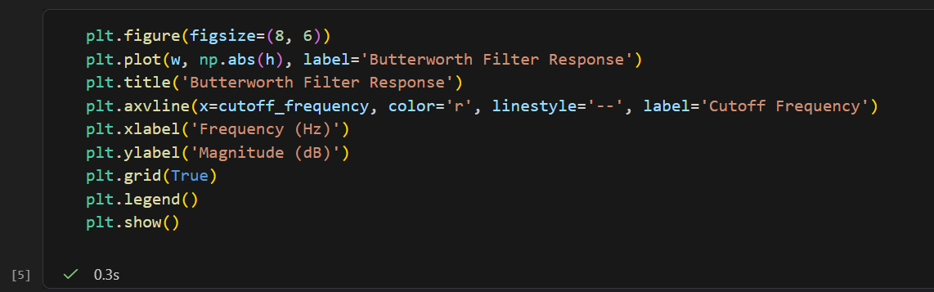

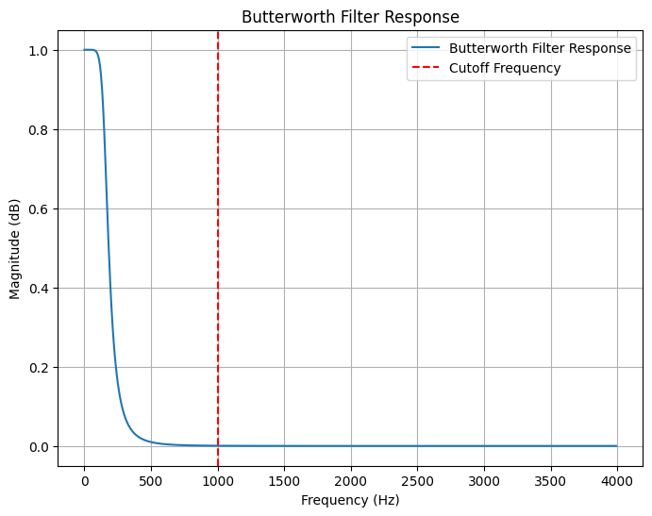

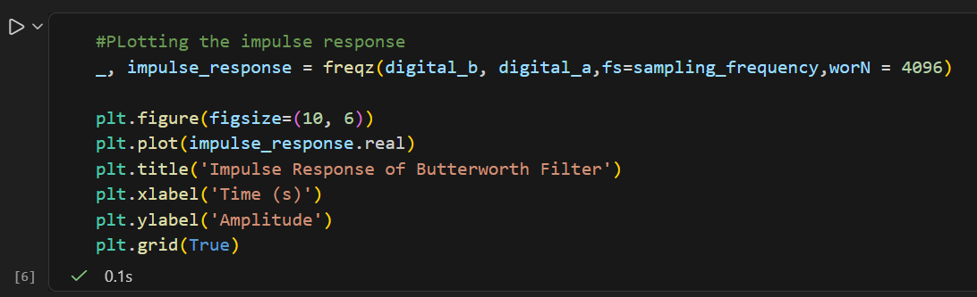

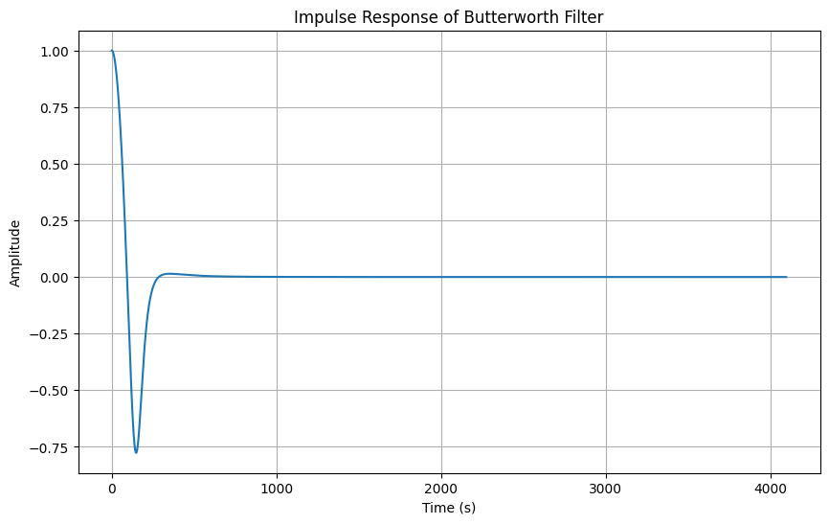

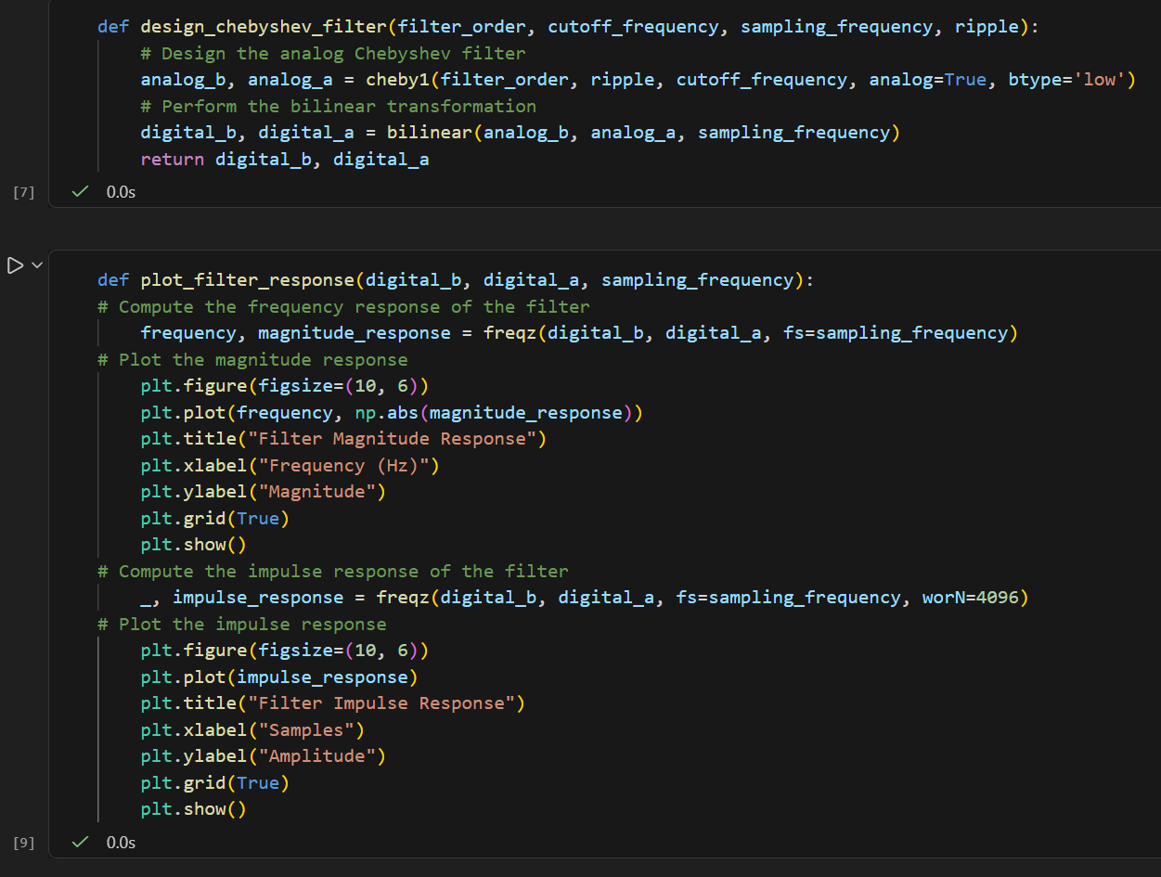

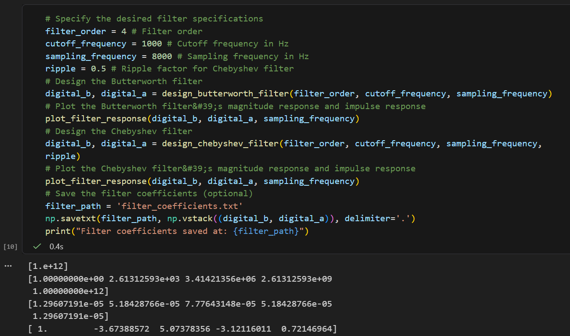

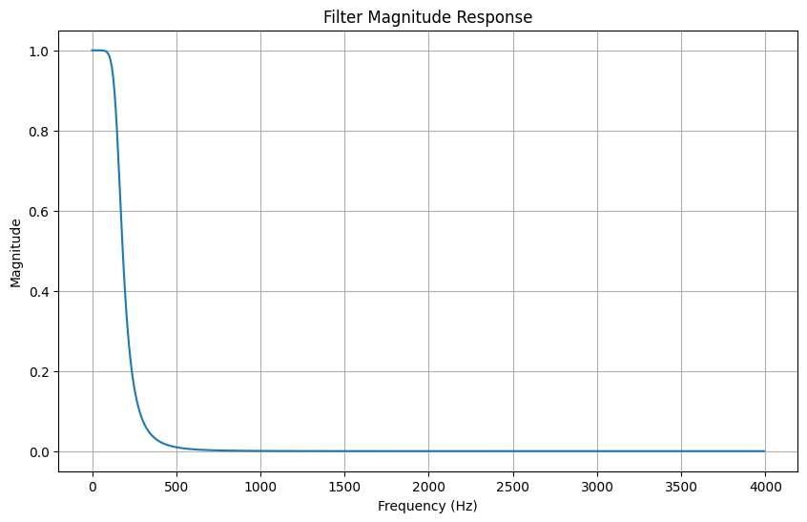

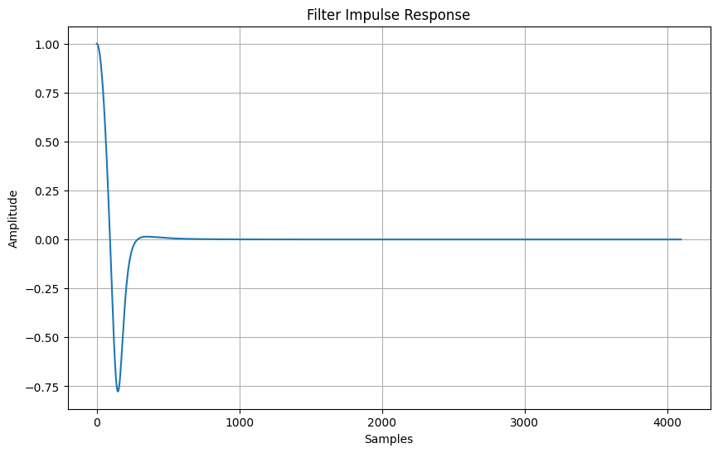
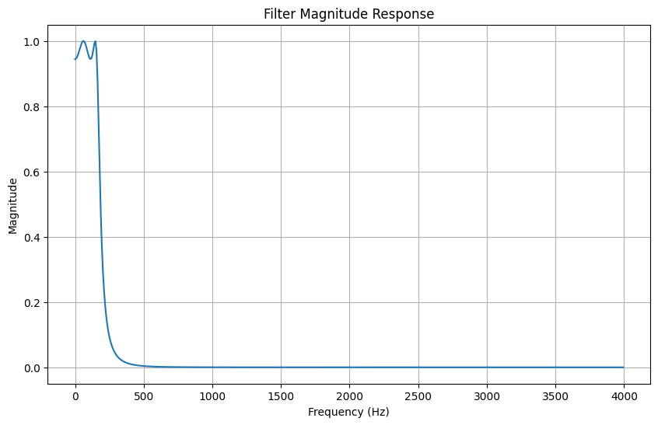

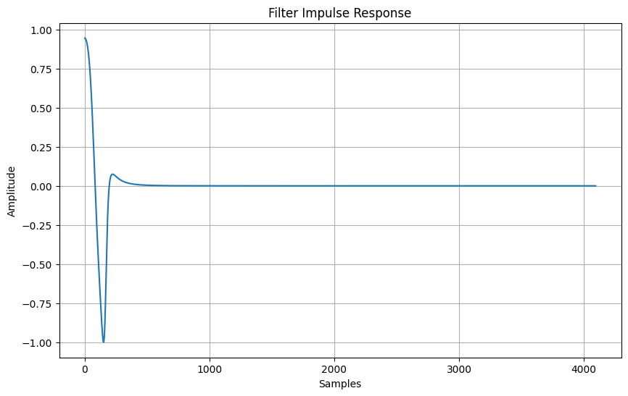

Conclusion:
In this experiment, we successfully designed Butterworth and Chebyshev filters using the bilinear transformation method. We understood how analog filters can be converted into digital filters and observed the differences in their frequency responses. The experiment helped us understand the importance of these filters in digital signal processing and how they are used for effective frequency selection and noise reduction.

